PRACTICING WEEK 5
Course: Data Engineering
Name: Meng Oudom
Goal: Last week you have some data for online store. You already ingested API data into OLTP tables: customers, products, orders, order_items. Now you must serve the data to 3 consumers:
- BI team (dashboards, reports)
- Ops team (near real-time alerts)
- Sales team (needs scores inside CRM → Reverse ETL)

- Build a small data mart (star-style) using SQL views
Create 3 views in your warehouse layer (or pretend schema mart):
- mart.dim_customer
- customer_id, name, phone
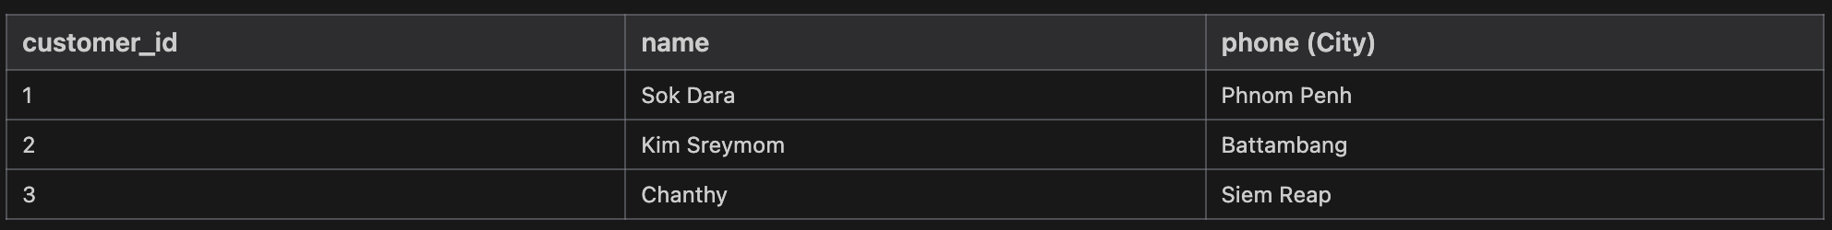
- mart.dim_product
- product_id, name, category, price
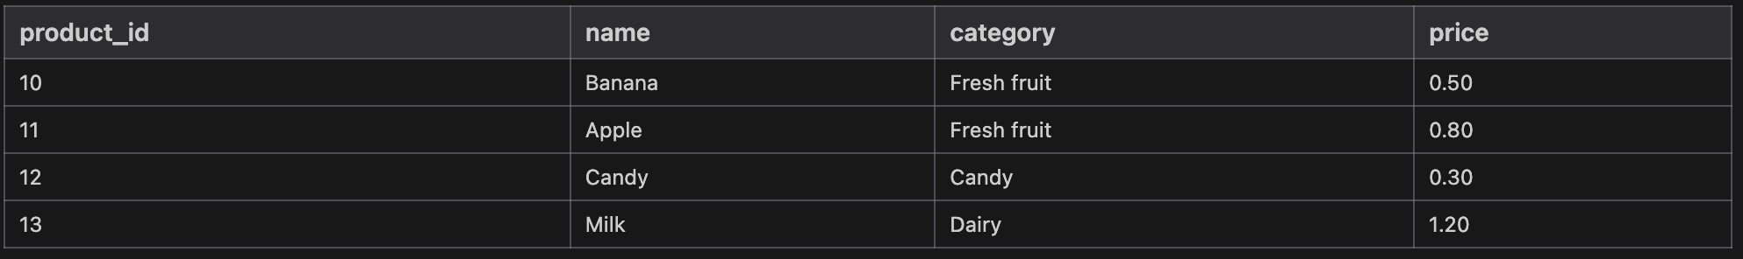
- mart.fact_sales (grain: order_item)
- order_id, order_date, store, customer_id, product_id, quantity, price, revenue
- where revenue = quantity * price

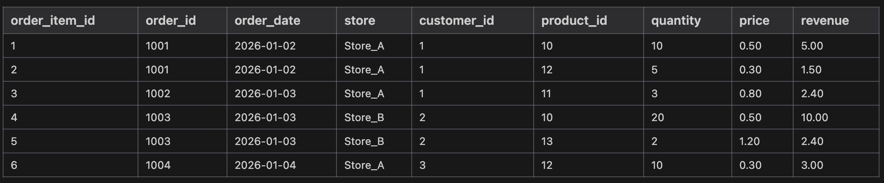
- Rules
- JOIN: orders + order_items + products
- Ensure quantity > 0 and price >= 0 (filter bad rows)

- Serve for Analytics using File Exchange
Write one SQL query that outputs a CSV-style result:
Columns:
- month (YYYY-MM)
- store
- total_orders
- total_revenue
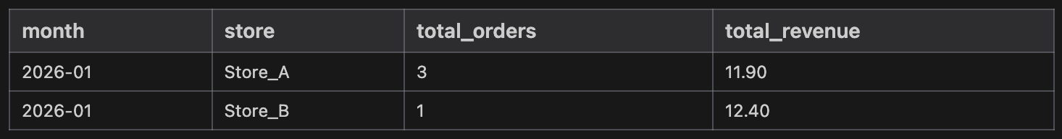
Then answer:
- When is file exchange a good idea?
+ It is a good idea for occasional sharing (e.g., weekly reports) when the consumer doesn't have technical access to the database or when you need to share a static snapshot of data with external partners who use tools like Excel or Google Sheets.
- What is the biggest limitation if you email Excel files?
+ The biggest limitation is the loss of the "Single Source of Truth." Once an Excel file is emailed, it becomes a static, disconnected copy. It's difficult to keep the data fresh, and different versions of the same report often circulate among teams, leading to data inconsistency and confusion.

- Query Federation
Assume:
- Warehouse has mart.fact_sales
- A Product API provides the latest product category changes (external source)
Write:
- A short explanation: why federation is useful for exploration
Query federation allows a user to query data across multiple disparate systems (e.g., a SQL warehouse and an external product API) as if they were in a single database, without having to first ingest and move all that data into a central storage layer.
It is extremely useful for exploration because:
- Speed to Insight: Data engineers don't need to build complex ETL pipelines just to "peek" at data or join a small amount of external data with internal facts.
- Access to Live Data: It allows joining historical warehouse data with "live" or "hot" data from external APIs or operational databases that hasn't been synced yet.
- Reduced Storage Costs: You don't pay to store data that you only need to query occasionally.
- One risk (production overload) + one control (limit, caching, read replica, etc.)
  - One Risk: Production Overload
Federated queries often translate into direct calls against the source systems' resources (CPU, Memory, IO). A complex join involving a large warehouse table and a production transactional database (or API) could significantly slow down or даже crash the production system by consuming its resources or locking tables.
  - One Control: Read Replicas / Caching
To mitigate this risk, query federation should ideally target a Read Replica of the production database instead of the primary instance. Additionally, implement Caching layers or query limits (timeouts and row limits) to ensure that expensive cross-source queries don't run indefinitely and degrade source performance.

- Reverse ETL
Sales team works in CRM, not in warehouse. Reverse ETL sends processed/scored data back to operational tools.
- Create a table crm_customer_scores(customer_id, spend_score, updated_at) OR add a column in customers (if allowed).
- Compute spend_score = total_spend from vw_order_enriched (customer-level aggregation).
- Insert/update scores into crm_customer_scores.

- Deliverable: SQL 04_reverse_etl.sql + screenshot/result table.

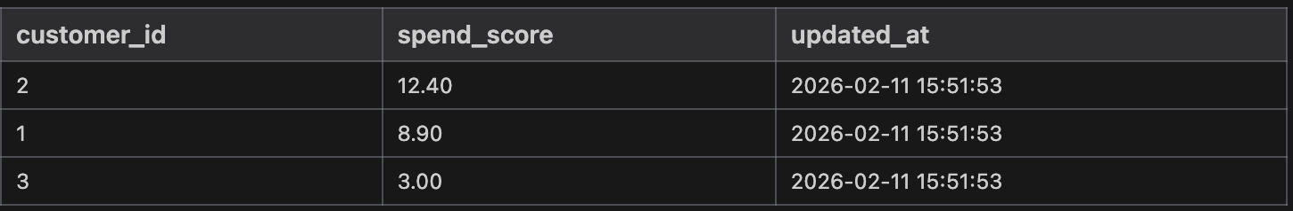

Homework

(Work as groups)

    - Streaming Systems (near real-time)

Serving data for operational analytics (real-time dashboards/alerts)
Requirements: Design 1 event + 1 alert using Kafka + Python consumer

  - Define an event schema (JSON): order_created
Your order_created event must include these fields:
- event_id
- event_time
- order_id
- customer_id
- store
- total_items
- total_amount
  - Create an alert rule
Trigger an alert when:
- total_amount > 500 OR
- total_items > 20
- Tools (Kafka + Python Consumer)
Use the following tools:
- Docker Desktop
- Kafka via docker-compose
- Python consumer using:
  - confluent-kafka or
  - kafka-python
- Kafka topic: orders

    - Build Machine Learning Model (Linear Regression: Predict order_total)
- Target is continuous (fits regression).
- Uses your real tables from last week (orders + items + products + store).
Practicing

- What do you need to do?
- Build ML dataset (one row per order) with features:
  - total_qty
  - item_lines (count of order_items)
  - avg_price, max_price
  - store (categorical → one-hot)
  - day_of_week (from order_date)
  - Target: order_total
- Train/test split (80/20)
- Train Multiple Linear Regression
- Evaluate: MAE, RMSE, R²
- Explain coefficients: which features increase order_total?
- Save predictions as order_predictions.csv

Deliverables
- homework_ml.ipynb (or .py)
- order_predictions.csv

